

**Faculty of Engineering & Technology – Electrical & Computer Engineering Department**

**First Semester 2022 – 2023**

**Circuits and electronics lab**

**ENEE2103**

**Report Experiment 10**

***The Operational Amplifier***

**Name: Amal Ziad**

**ID: 1192141**

**Section: 2**

**Instructor: Dr. Mohammad Jehad Al Juba**

**TA: Eng. Yazan Yousef**

**Date: 6th Jan 2023**

# Abstract

The aim of this experiment is to get to know different applications of the op. amp circuits such as adding, voltage follower, comparator, integrator, differentiator, and Schmitt trigger.

**Table of Contents**

Abstract 2

Table of figures 4

Table of tables 4

1. Theory 5

• Op. amp definition 5

• Op. amp characteristics 5

1. Op amp adding app. 5

2. Voltage follower app. 6

3. Comparator app. 6

4. Integrator and differentiator app. 7

5. Schmitt trigger 7

6. Active clipping circuit 8

2. Procedure 8

I. Adding application 8

II. Voltage follower application 9

III. Comparator Application. 9

IV. Integrator and differentiator 10

V. Schmitt trigger 11

VI. Active clipping circuit 11

3. Data calculation and results 12

I. Adding app. 12

II. Voltage follower app. 12

III. Comparator app. 13

IV. Integrator and differentiator 14

V. Schmitt trigger 15

VI. Active clipping circuit 16

4. Conclusion 17

# Table of figures

Figure ‎2.1 op. amp regions 5

Figure ‎2.2 op amp adder description 6

Figure ‎2.3 Voltage follower circuit 6

Figure ‎2.4 comparator circuit description 6

Figure ‎2.5 differentiator circuit 7

Figure ‎2.6 integrator circuit 7

Figure ‎2.7 Schmitt trigger circuit and graph of its output 8

Figure ‎3.1 Adding application experiment circuit 9

Figure ‎3.2 Voltage follower experiment circuit 9

Figure ‎3.3 Comparator experiment circuit 10

Figure ‎3.4 integrator experiment circuit 10

Figure ‎3.5 differentiator experiment circuit 10

Figure ‎3.6 schmitt trigger experiment circuit 11

Figure ‎3.7 Active clipping circuit 11

Figure ‎4.1 graph of Vo of voltage follower app. 12

Figure ‎4.2 Vo of comparator (-1.5 <Vi<1.5) 13

Figure ‎4.3 Vo of comparator (Vi=-Vsat) 14

Figure ‎4.4 Vo of comparator (Vi=+Vsat) 14

Figure ‎4.5 integration for sin wave Figure ‎4.6 integration for triangular wave Figure ‎4.7 integration for square wave 14

Figure ‎4.8 derivative of square wave Figure ‎4.9 derivative of triangular wave Figure ‎4.10 derivative of sine wave 15

Figure ‎4.11 Vo of Schmitt trigger 15

Figure ‎4.12 output of clipping circuit Figure ‎4.13 output of reversed diodes of clipping circuit 16

# Table of tables

Table ‎4‑1 results of adding app. 12

Table ‎4‑2 results of voltage follower app. 13

# Theory

## Op. amp definition

Op. amp is an analog circuit block that takes a differential voltage input and produces a single-ended voltage output. Op amps usually have three terminals: two high-impedance inputs and a low-impedance output port. The inverting input is denoted with a minus (-) sign, and the non-inverting input uses a positive (+) sign. Operational amplifiers work to amplify the voltage differential between the inputs, which is useful for a variety of analog functions including signal chain, power, and control applications.[1]

## Op. amp characteristics

𝑽o= {+𝑽𝒔𝒂𝒕 ,𝒗𝒅 > $\frac{Vsat}{Ad}$

𝑨𝒅 𝒗𝒅 , $\frac{Vsat}{Ad}$ > 𝒗𝒅 > $\frac{-Vsat}{Ad}$

−𝑽𝒔𝒂𝒕 ,𝒗𝒅 < $\frac{-Vsat}{Ad}$}

Where vd= V(+) - V(-) , as shown in fig.2.1.

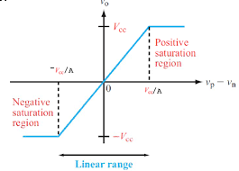

Figure ‎1.1 op. amp regions

## Op amp adding app.

Op-amp adder is used to sum the input voltage of two or more sources into a single output voltage. The input voltages are applied to the inverting terminal of the op-amp. The inverting terminal is grounded. The output voltage is proportional to the sum of the input voltages.[2] As shown in fig.2.2.

The formula: Vo= $\frac{Rf}{Ri}Vi$

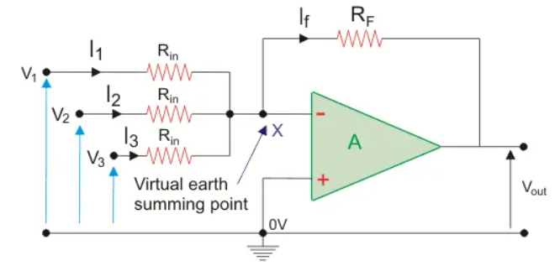

Figure ‎1.2 op amp adder description

## Voltage follower app.

Voltage follower can be defined as when the output of the op-amp circuit follows the input of the op-amp directly. So both the input and output voltages are the same. This circuit doesn’t supply any amplification. As a result, voltage gain is equivalent to 1. It is also known as unity gain, buffer & isolation amplifier.[3] As shown in fig.2.3.

The formula: Vo=Vin

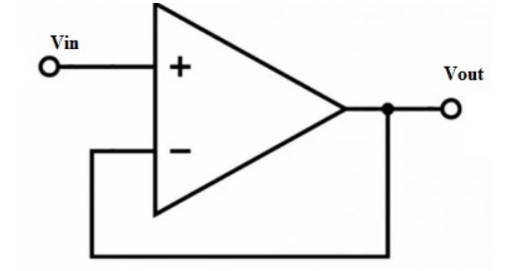

Figure ‎1.3 Voltage follower circuit

## Comparator app.

The Op-amp comparator compares one analogue voltage level with another analogue voltage level, or some preset reference voltage, VREF and produces an output signal based on this voltage comparison. In other words, the op-amp voltage comparator compares the magnitudes of two voltage inputs and determines which is the largest of the two.[4] As shown in fig.2.4. The formula: Vo = Ao(V+ – V-)

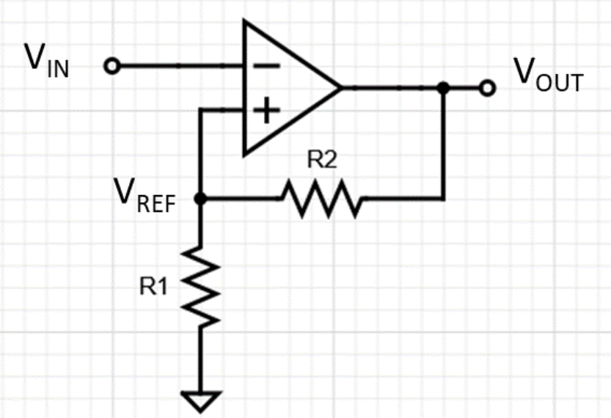Figure ‎1.4 comparator circuit description

## Integrator and differentiator app.

An op-amp based differentiator produces an output, which is equal to the differential of input voltage that is applied to its inverting terminal. As shown in fig.2.5.

Formula: V0=−RC $\frac{dVi}{dt}$

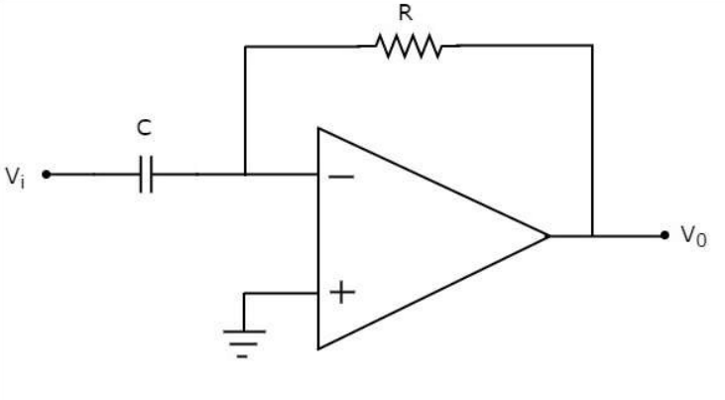

Figure ‎1.5 differentiator circuit

An op-amp based integrator produces an output, which is an integral of the input voltage applied to its inverting terminal.[5] As shown in fig.2.6.

Formula: Vo=− $\frac{1}{RC}$ ∫Vtdt

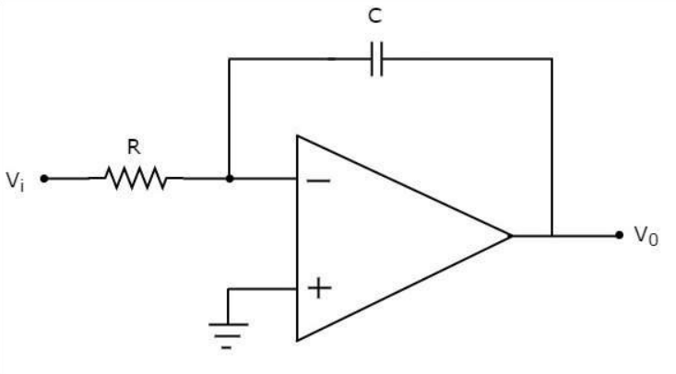

Figure ‎1.6 integrator circuit

## Schmitt trigger

Schmitt trigger is an electronic circuit that adds hysteresis to the input-output transition threshold with the help of positive feedback. Its output remains in either of the stable states, or the output changes from one stable state to other.[6] As shown in fig.2.7.

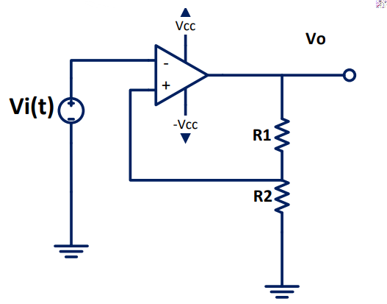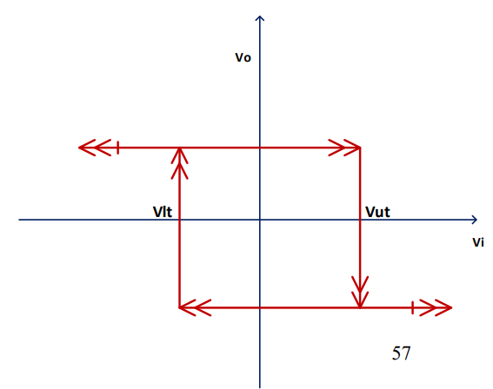

Figure ‎1.7 Schmitt trigger circuit and graph of its output

Formula: Vh= Vut-Vlt

Vut= $\frac{R2}{R1+R2}(+Vsat)$

Vlt= $\frac{R2}{R1+R2}(-Vsat)$

## Active clipping circuit

In op-amp clipper circuits a rectifier, diode may be used to clip off a certain portion of the input signal to obtain a desired o/p waveform. The diode works as an ideal diode (switch) because when on, the voltage drop across the diode is divided by the open loop gain of the op-amp.[7]

# Procedure

## Adding application

The circuit here was connected as shown in figure 3.1, where V1 was controlled by potentiometer. Moreover, V2 is obtained from the variable dc source on the trainer. Measures of Vo were obtained.

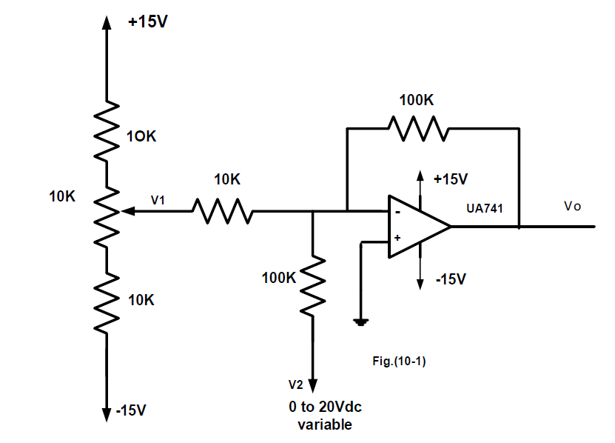

Figure ‎2.1 Adding application experiment circuit

## Voltage follower application

The circuit here was connected as shown in figure 3.2. The function generator (Vi(t)) frequency was set to 100Hz and 2 Vp-p. After that, RL has been changed from 220Ω to 1kΩ. Measures of Vo for both cases were obtained.

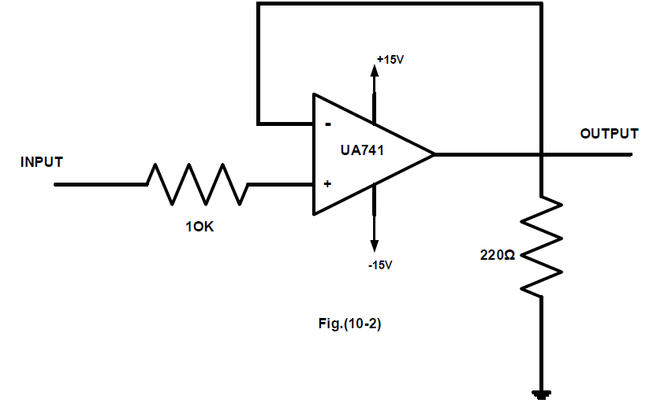Figure ‎2.2 Voltage follower experiment circuit

## Comparator Application.

The circuit here was connected as shown in figure 3.3. The function generator (Vi(t)) frequency was set to 1 kHz and 2 Vp-p. At the same time, dc reference voltage was changed to be from -1.5V to 1.5V. Screenshots of the oscilloscope were obtained.

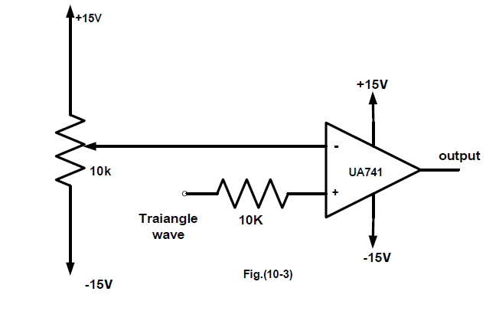Figure ‎2.3 Comparator experiment circuit

## Integrator and differentiator

The circuit here was connected as shown in figure 3.3. The function generator (Vi(t)) frequency was set to 30 Hz and 2 Vp-p. The frequency has been changed as the graph needed and screenshots of the oscilloscope were obtained for sine wave, triangular and sawtooth.

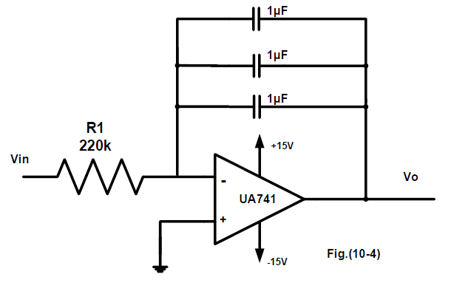Figure ‎2.4 integrator experiment circuit

The circuit here was connected as shown in figure 3.5. The function generator (Vi(t)) frequency was set to 30 Hz and 2 Vp-p. The frequency has been changed as the graph needed and screenshots of the oscilloscope were obtained for sine wave, triangular and sawtooth.

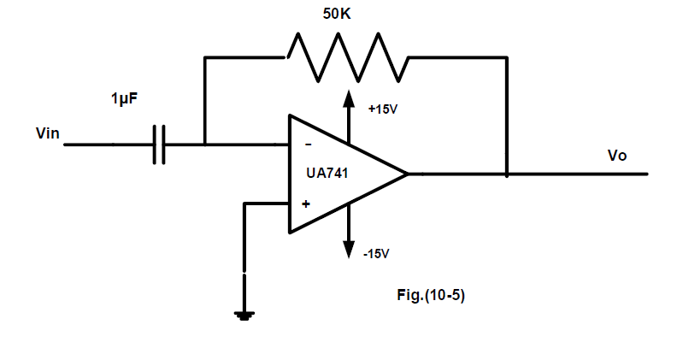Figure ‎2.5 differentiator experiment circuit

## Schmitt trigger

The circuit here was connected as shown in figure 3.6. The function generator (Vi(t)) frequency was set to 1 kHz and 15 Vp-p. Screenshots and V lower and upper threshold were obtained.

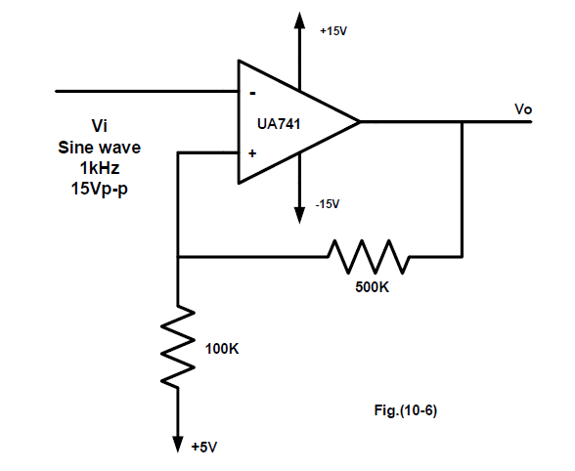Figure ‎2.6 schmitt trigger experiment circuit

## Active clipping circuit

The circuit here was connected as shown in figure 3.7. The function generator (Vi(t)) frequency was set to 1 kHz and 15.2 Vp-p. Screenshots were taken.

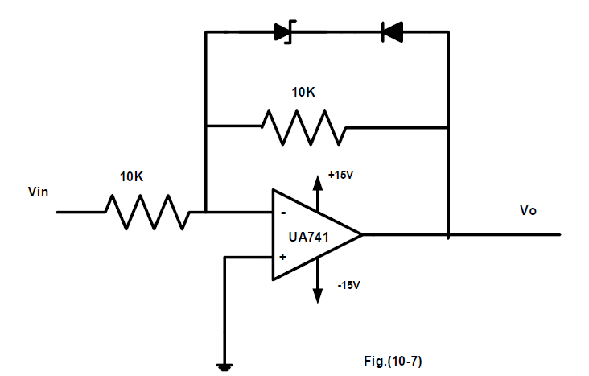Figure ‎2.7 Active clipping circuit

# Data calculation and results

## Adding app.

The results of this part is shown in table 4-1.

|  |  |  |  |
| --- | --- | --- | --- |
| Input voltage | | Output voltage | |
| V1 | V2 | Vo | Calculated Vo |
| 0.52 | 2.1 | 7.016 | 7.3 |
| 0.12 | 6.2 | 6.9 | 7.4 |
| 0.32 | 4 | 7.4 | 7.2 |
| -0.96 | 2.1 | -7.4 | -7.5 |
| -1.16 | 4.06 | -7.5 | -7.54 |
| -1.52 | 4.14 | -9.03 | -11.06 |

Table ‎3‑1 results of adding app.

The equation used to calculate Vo= $\frac{Rf}{Ri1}V1+\frac{Rf}{Ri2}V2$ = 10V1+V2

**Discussion:**

As the results shows, the circuit sums the 2 input voltages of the (-) terminal of the op amp. There is small errors between the calculated and practical values of Vo due to that R values are not at exact numbers.

## Voltage follower app.

The screenshots of the result of the circuit is shown in fig.4.1

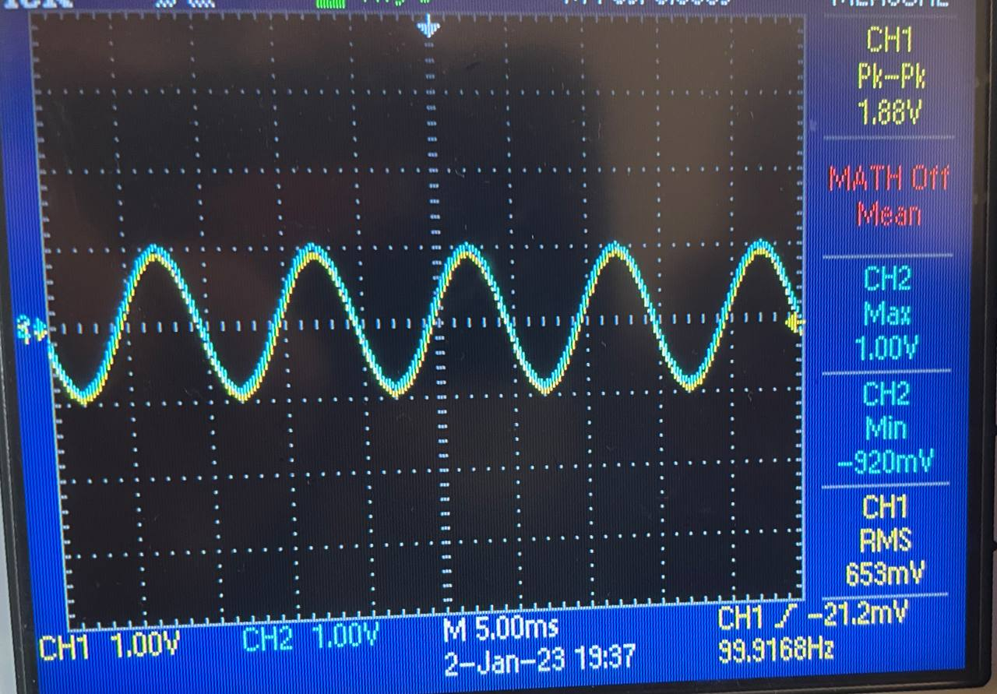

Figure ‎3.1 graph of Vo of voltage follower app.

The measures of this part is shown in table 4-2.

|  |  |  |  |  |  |  |  |  |  |  |  |  |
| --- | --- | --- | --- | --- | --- | --- | --- | --- | --- | --- | --- | --- |
| Vi(dc) | 1.03 | 2.02 | 3.02 | 4 | 5.03 | 6.02 | 7.03 | 8 | 10 | 12 | 14.02 | 15.02 |
| Vo (R=220Ω) | 1.03 | 2.02 | 3.02 | 4 | 5.03 | 5.6 | 5.6 | 5.65 | 5.66 | 5.67 | 5.67 | 5.68 |
| Vo (R=1 kΩ) | 1.05 | 1.99 | 2.93 | 3.9 | 4.93 | 5.91 | 6.93 | 7.91 | 9.95 | 12.01 | 13.04 | 13.04 |

Table ‎3‑2 results of voltage follower app.

**Discussion:**

As the results shows, the voltage follower acts as a buffer that doesn’t change voltage value. For Vo when using R=220Ω, the values after 6 Vi got stuck in its place and didn’t change, this due to that R is too smaller of Rs=10kΩ, this difference may affect unity gain Av.

* The circuit is similar in its properties of emitter follower (both acts as buffer), that emitter follower presenting a high impedance to the circuit that is driving it, while offering a lower impedance output, the same for our circuit.
* The circuit is used as buffer. Buffer circuits are mainly used where a signal has very low current input, which needs to be increased maintaining the same voltage levels.

## Comparator app.

The screenshots resulted from this part are shown in fig.4.2, fig.4.3, and fig.4.4.

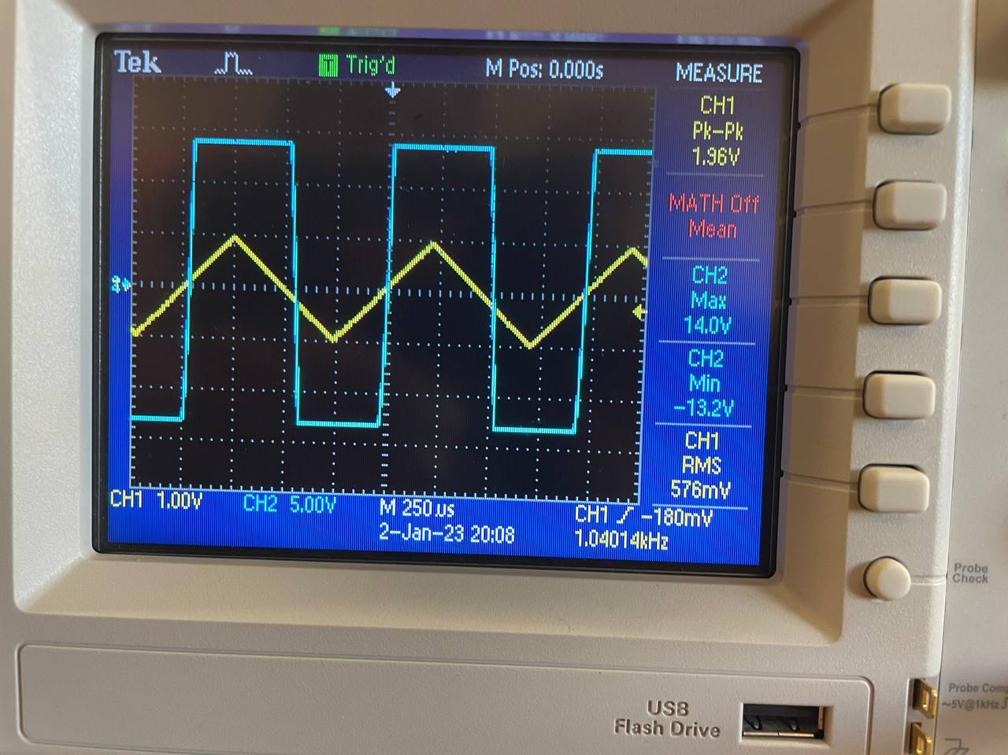

Figure ‎3.2 Vo of comparator (-1.5 <Vi<1.5)

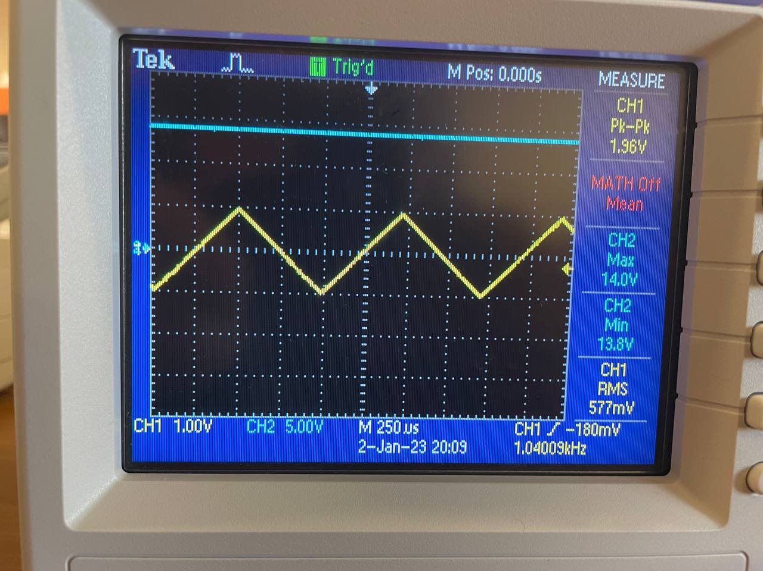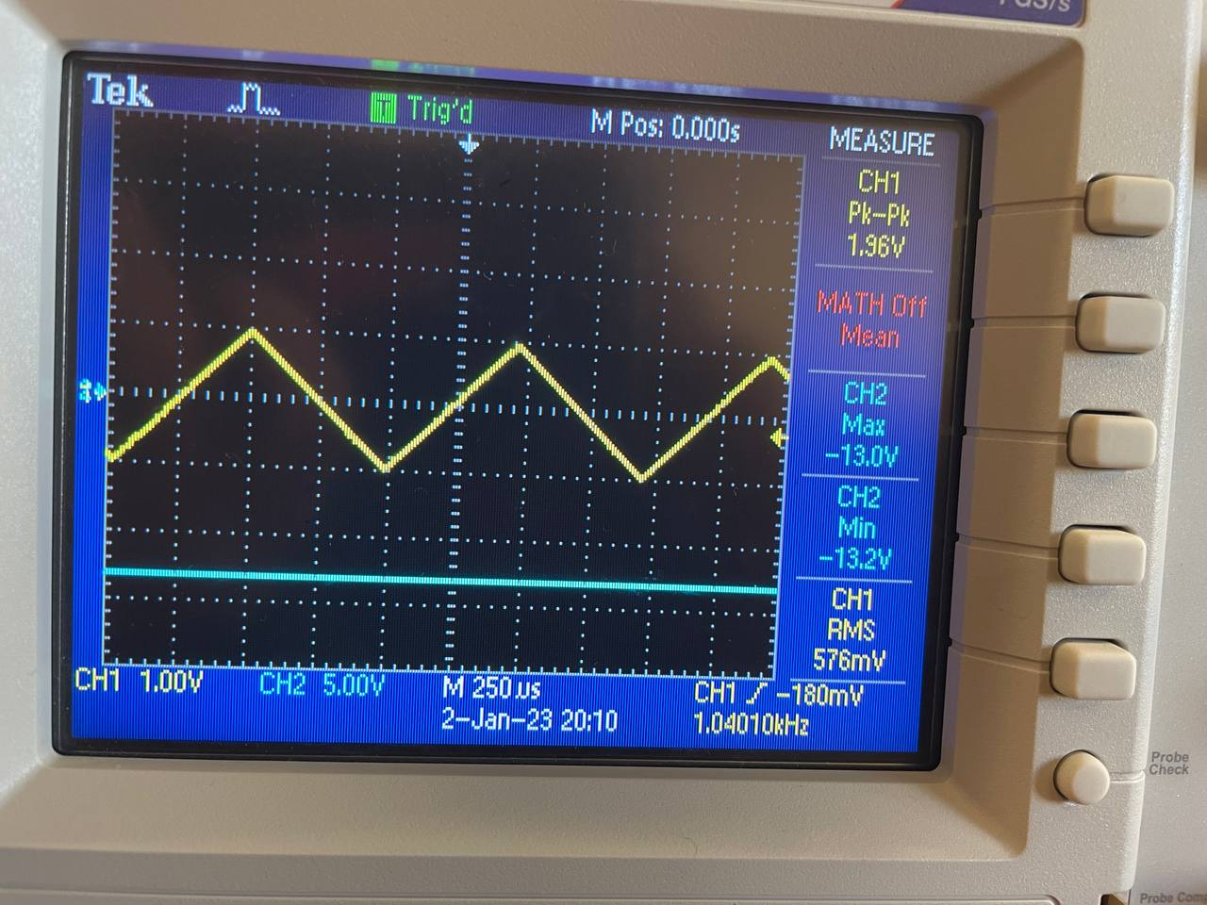

Figure ‎3.3 Vo of comparator (Vi=-Vsat)

Figure ‎3.4 Vo of comparator (Vi=+Vsat)

**Discussion:**

As shown in the graphs, the comparator compares 2 input voltages (V(+)-V(-)). In fig.4.2, the V(-) was between -1.5 and 1.5, so the output is square wave because the same value was compared with 2Vp-p in V(+). In fig.4.3, the V(-) =-Vsat which is -15+2=-13V, so Vo=2- -13=+15V, which is constant and above the triangular wave. The same in fig.4.4, but V(-)=Vsat=15-2=13V, so Vo=2-13=-11V.

* This circuit is used in devices such as relaxation oscillators, analog to digital converters (ADCs), also in the devices that are used to measure analog signals.
* The similarity between this circuit and the diff amp is that the graph in fig.4.2 is close to the graph of the differential of triangular wave but not exactly the same.

## Integrator and differentiator

The screenshots resulted from integrator part are shown in fig.4.5, fig.4.6, and fig.4.7.

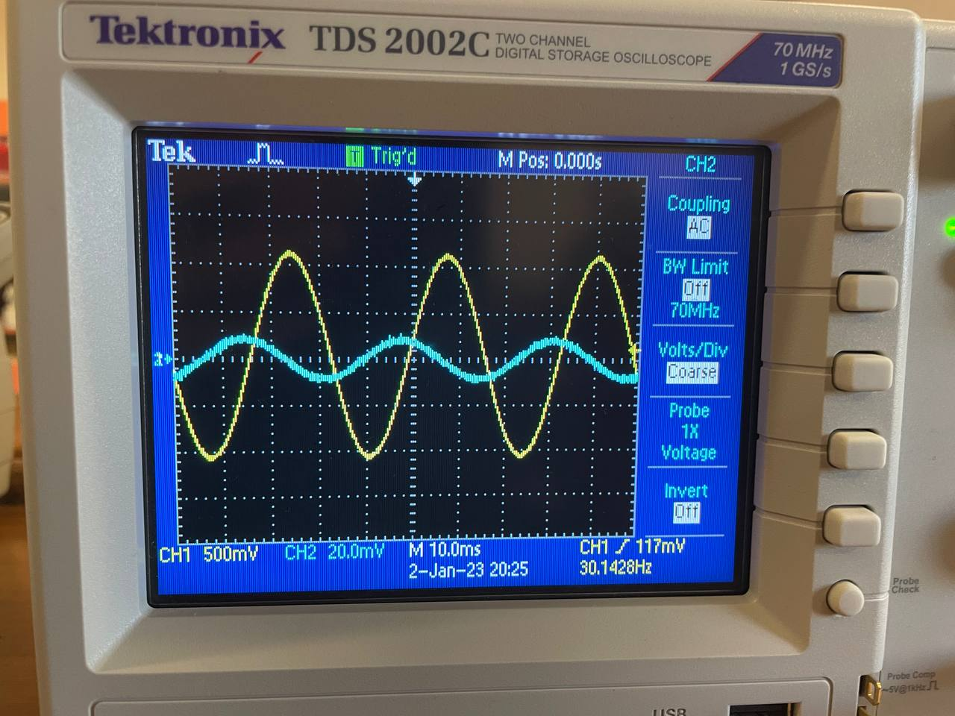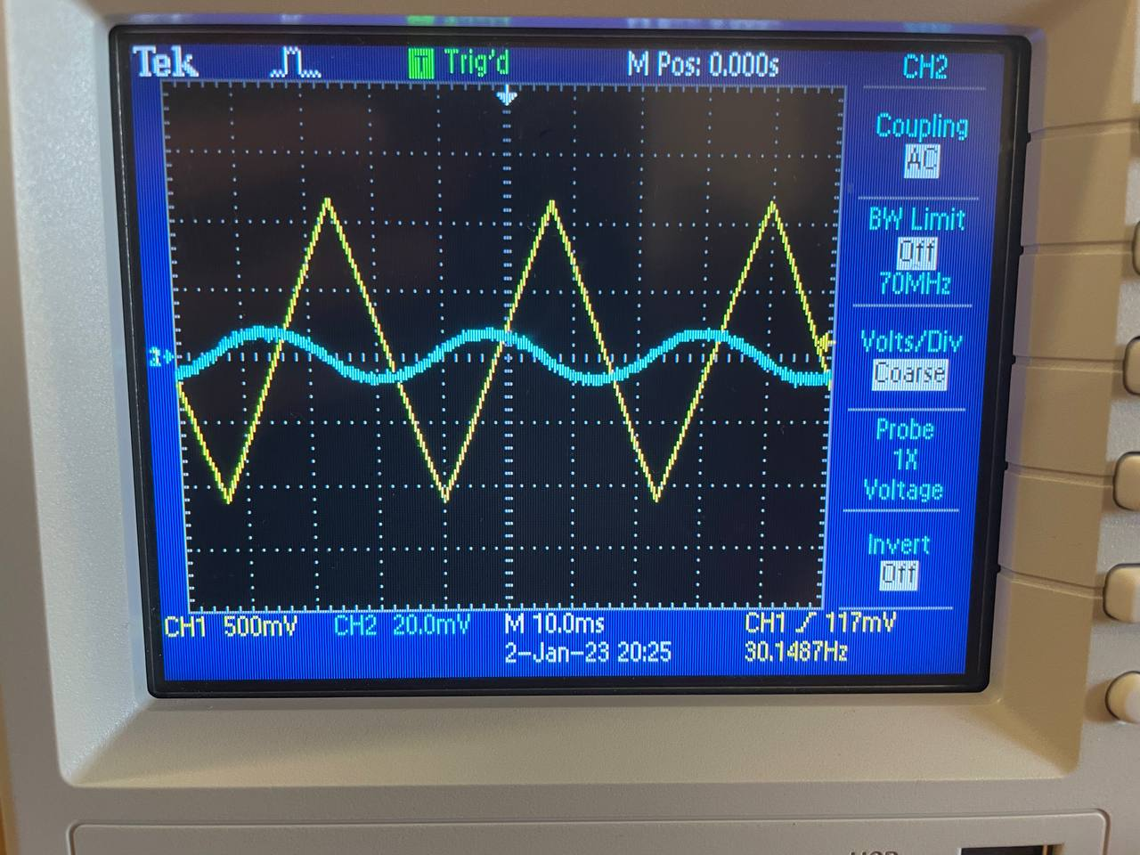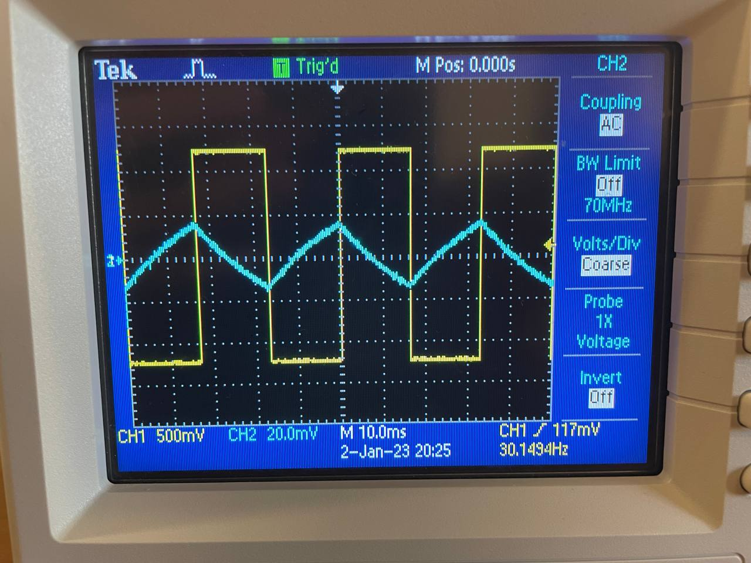

Figure ‎3.5 integration for sin wave Figure ‎3.6 integration for triangular wave Figure ‎3.7 integration for square wave

**Discussion:**

As shown in the figures, each wave with its integration, we know that the integration of sine wave is cosine wave. The integration of traingular wave is sine wave. The integration of square wave is traingular wave.

The screenshots resulted from differentiator part are shown in fig.4.8, fig.4.9, and fig.4.10.

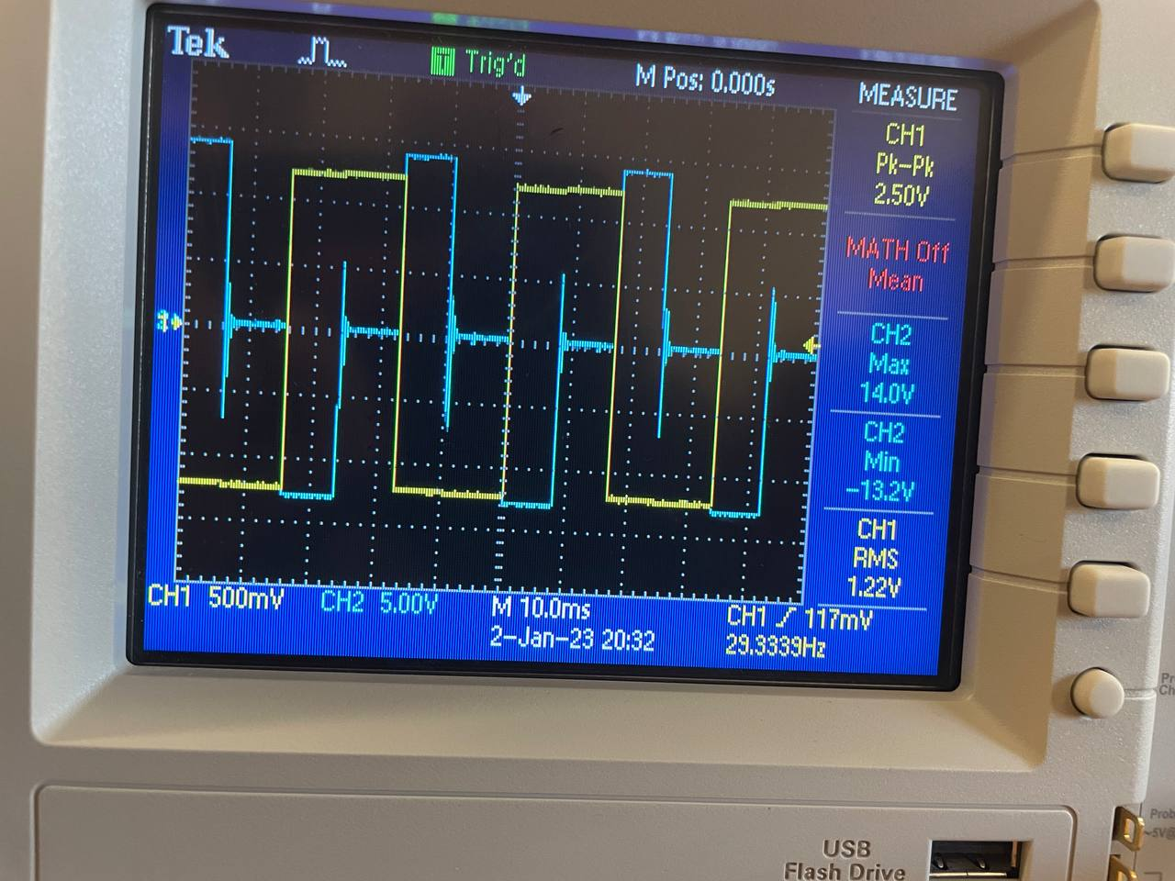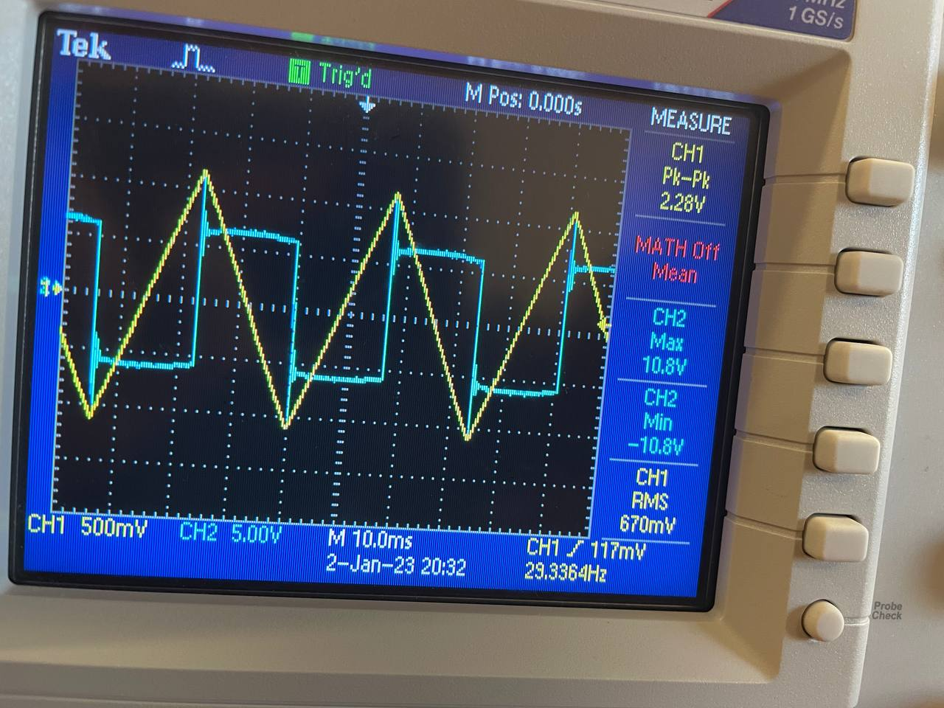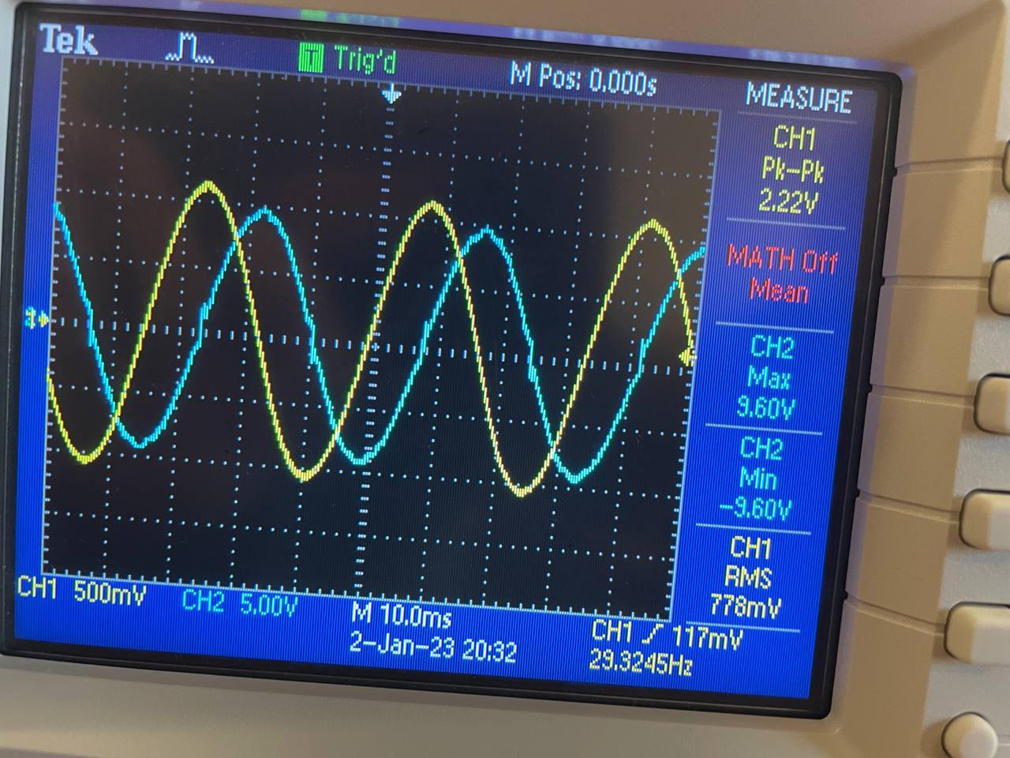

Figure ‎3.8 derivative of square wave Figure ‎3.9 derivative of triangular wave Figure ‎3.10 derivative of sine wave

**Discussion:**

As shown in the figures, each wave with its derivative, we know that the differentiation of sine wave is cosine wave. The differentiation of traingular wave is almost squar wave. The differentiation of square wave is as train of +-squares and zero.

## Schmitt trigger

The screenshot resulted from this part is shown in fig.4.11.

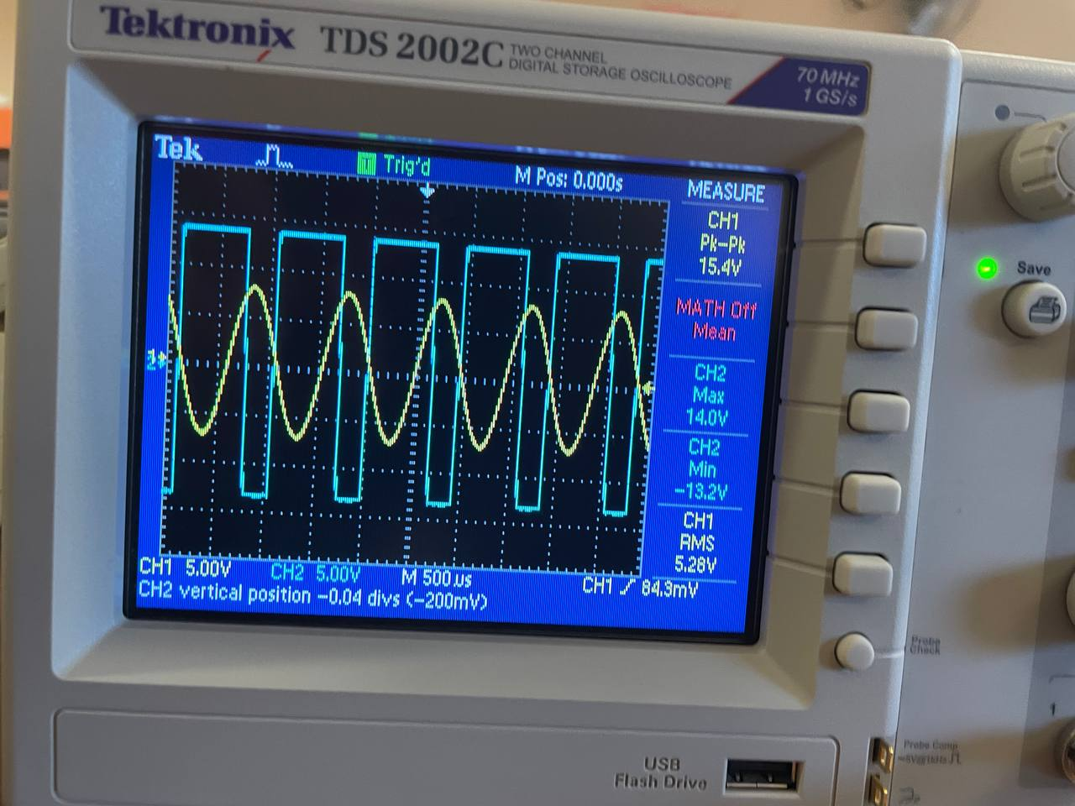

Figure ‎3.11 Vo of Schmitt trigger

The measured VUT=7.2V +Vsat=13V -Vsat=-13V

The calculated VUT: assume Vo=+Vsat=13V

V(-)=Vi(t) , V(+)= $\frac{500k}{500k+100k}\left(5\right)+\frac{100k}{500k+100k}(13)$ =6.33V

As long as 6.33>Vi(t), Vo=+Vsat 🡪 VUT=6.33V.

The measured VLT=1.4V

The calculated VLT: assume Vo=-Vsat=-13V

V(-)=Vi(t) , V(+)= $\frac{500k}{500k+100k}\left(5\right)+\frac{100k}{500k+100k}(-13)$ =2V

As long as 2<Vi(t), Vo=-Vsat 🡪 VLT=2V.

**Discussion**

As the circuit shows, there’s a lower and upper threshold. But there’s error =-0.87 for UT and 0.6 for LT. This is may be due to inaccuracy in taking measures. The figure above shows that Schmitt trigger changes sine wave to squared wave.

## Active clipping circuit

The screenshots taken are shown below.

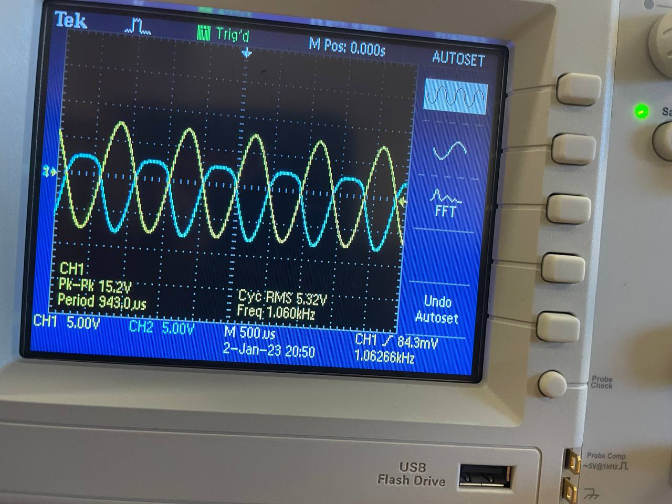 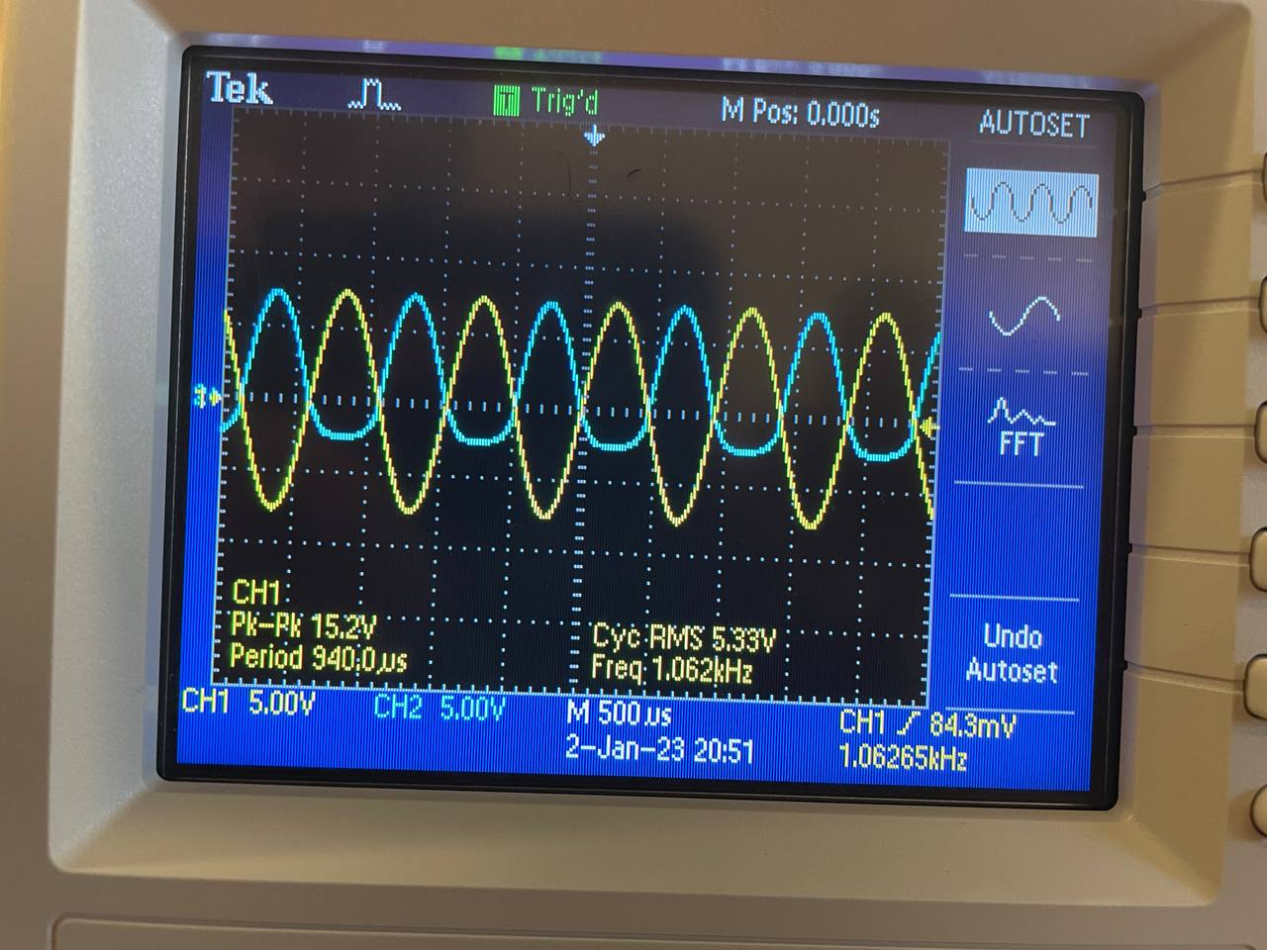

Figure ‎3.12 output of clipping circuit Figure ‎3.13 output of reversed diodes of clipping circuit

**Discussion:**

As shown, the clipping circuit clips the sine wave from one side. In general, clipping circuits used to select, for purposes of transmission, that part of a signal waveform, which lies above or below the predetermined reference voltage level.

# Conclusion

In this experiment, we have gained knowledge and learnt better about the different applications of op amp. In addition, we had understood the properties of each circuit and the difference between other similar circuits. We also comprehended the graphs and understood if we change in the values of the circuit in either voltages or resistors, and their effects on the circuits.

1. <https://www.monolithicpower.com/en/operational-amplifiers> in 6/1 at 3:10pm
2. <https://www.electrical4u.com/applications-of-op-amp/#:~:text=Op%20Amp%20Applications%20as%20Adder,terminal%20of%20the%20op-amp>. In 6/1 at 4:29pm
3. <https://www.elprocus.com/what-is-voltage-follower-working-its-applications/> in 6/1 at 4:33pm
4. <https://www.electronics-tutorials.ws/opamp/op-amp-comparator.html> in 6/1 at 4:40pm
5. <https://www.tutorialspoint.com/linear_integrated_circuits_applications/linear_integrated_circuits_applications_differentiator_and_integrator.htm> in 6/1 at 4:50pm
6. <https://www.electronicshub.org/schmitt-trigger-basics/> in 6/1 at 4:54pm
7. <https://www.brainkart.com/article/Clipper-and-clipper-using-Operational-Amplifier_36014/#:~:text=In%20op-amp%20clipper%20circuits,gain%20of%20the%20op-amp>. In 6/1 at 8:53pm